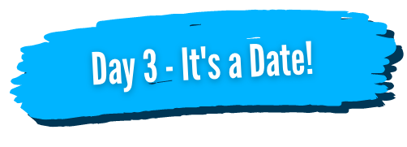

Take your list from yesterday and break it down to the 6 most important goals you want from 2021.

If you feel that some are as equally as important as others, ask yourself - which would your like to achieve first next year and what would make the most difference in your life?

Now…which is the MOST important, just ONE, that you would like to achieve next year?

State in the positive and set a date! I.e. I want to lose weight (negative) I want to be in a size 12 dress (positive) by 29th June 2021.

You can do this for the remaining 5 if you would like but keep focused on the ONE most important goal!

